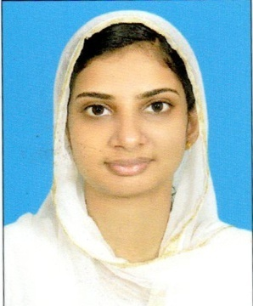

**RAFEESA.P.C**

[**rafeesapc00@gmail.com**](mailto:rafeesapc00@gmail.com)

**8547172776**

|  |
| --- |
|  |

###### **CAREER OBJECTIVE**

To become successful software professional, making the best use of my skills and talent for an innovative, value driven organization that ensures mutual growth and also always believing in giving the best to get the best out of the best is my aim. Seeking experience and a responsible position where I can utilize my talents & expertise to the fullest potential & to acquire good working skills in a Professional organization

**CAREER SUMMERY**

* Having knowledge on C#, .NET ,JAVA,C ,C++
* Ability to adopt and learn new technologies.
* Capacity to work in teams or individually and take up with responsibilities.

**TECHNICAL SKILLS**

* Familiar with OS: GNU/ Linux,Windows.
* Languages : C ,C++ , JAVA, C#,.NET ,HTML, CSS
* Database :MySQL, SQL Server 2005
* IDE :Microsoft visual studio 2010,Eclipse

**ACADEMIC QUALIFICATIONS**

* **Master Of Computer Application(MCA)**

AWH Engineering College, University of Calicut,Kerala,India

* **BSc Computer Science**

###### MG College Iritty, Kannur University ,Kerala,India

###### **ACADEMIC PROJECTS**

* Completed academic project entitled as “PULSE DETECTOR” for the fulfillment of my MCA degree at Kladeo technologies pvt ltd,Calicut,Kerala,India
* Completed a miniproject “semester registration automation “for our college as a part of my MCA course
* Developed website for Rubco pvt ltd Kannur,Kerala as part of my BSC computer science course.

**PROFESSIONAL TRAINING**

* Trained as junior software developer at Kladeo Technologies pvt ltd, Calicut,Kerala(as a part of internship).
* Trained at Integos intelligent solution kannur,kerala.

**PROFESSIONALEXPERIENCE**

* ITInstructor at Irikkur Rahmaniya Orphanage HSS(Kerala,Kannur)
* IT Instructor at VMMEMS MATTANUR

**PERSONAL DETAILS**

* Gender : Female
* Date of birth : 07/04/1989
* Nationality : Indian
* Marital Status : Married
* Address : NoorMahal(hm),Mattanur(PO),Kannur,Kerala

India, 670 702(PIN)

* Languages known : English, Malayalam (speak)

Hindi, Arabic (read & write)

The information furnished here above are true and correct to the best of my knowledge and belief.

RAFEESA.P.C